Step1:
Verify the installation:
docker --version
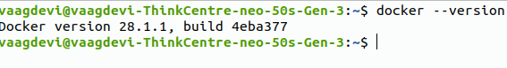

step2:Create a project
Create a folder:
mkdir docker-demo
cd docker-demo
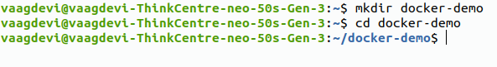

step3. Create the Python application
Nano app.py
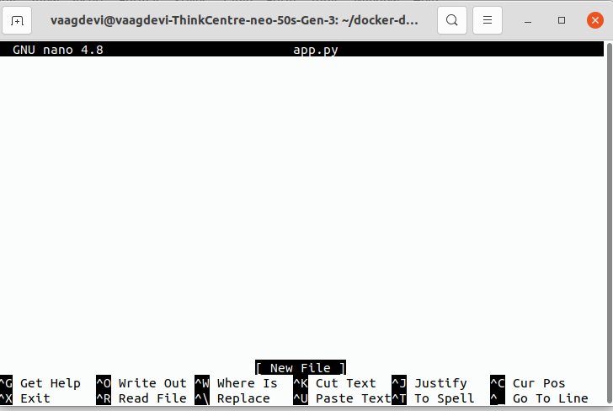

from flask import Flask

app = Flask(__name__)

@app.route("/")
def home():
return "Hello! This application is running inside Docker."

if __name__ == "__main__":
app.run(host="0.0.0.0", port=5000)
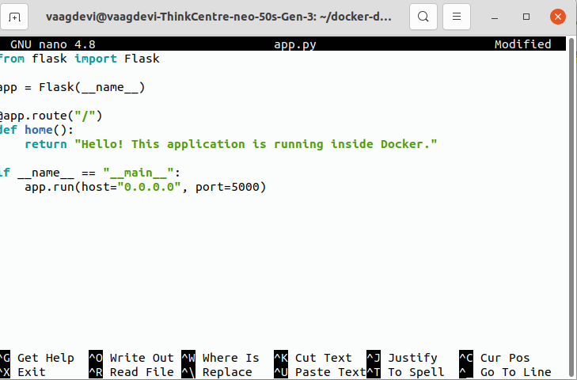

5. Save the file
In nano:
Press Ctrl + O
Press Enter to confirm app.py
Press Ctrl + X to exit
step6:
create a file requirment.txt
Flask==3.1.0
step7:create Dockerfile
nano Dockerfile
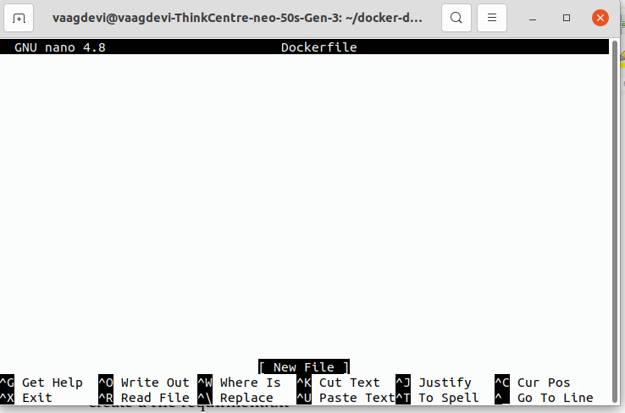

FROM python:3.12-slim

WORKDIR /app

COPY requirements.txt .

RUN pip install --no-cache-dir -r requirements.txt

COPY app.py .

EXPOSE 5000

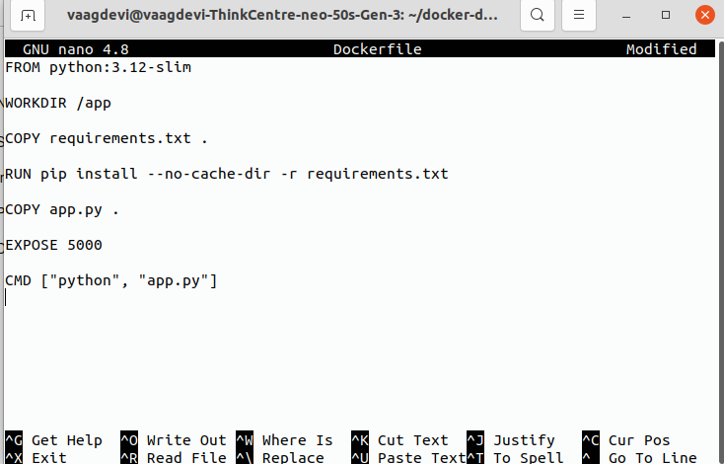
CMD ["python", "app.py"]

step7:list of files
ls

step8: Build the Docker image
Now we create a Docker image from our Dockerfile.
docker build -t my-python-app .

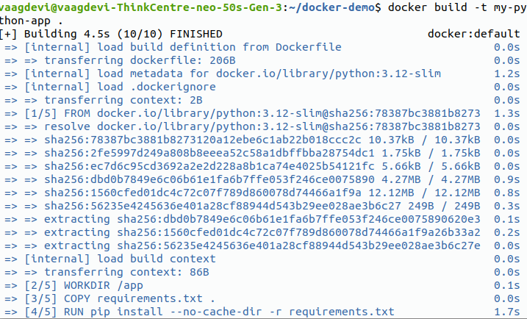

step9:
docker images
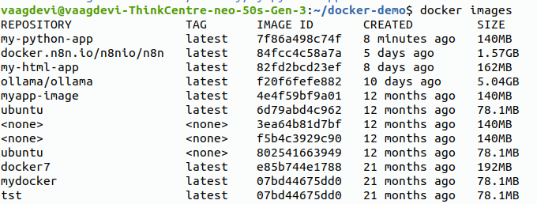

step10:Run the image
Now create a container from the image:
docker run -d -p 5000:5000 --name my-container my-python-app

check it
docker ps
step11:Open your application
http://localhost:5000

